Semi-quantitative petrographic characterization of Bronze Age quartzite tools – a multivariate approach

Mattias Sjölander1,✉

30 augusti, 2021

Text of abstract

1 Umeå University

✉ Correspondence: [Mattias Sjölander <[mattias.sjolander@umu.se](mailto:mattias.sjolander@umu.se)>](mailto:mattias.sjolander@umu.se)

Keywords: Spectroscopy; Quartzite; Characterization; Lithics

Highlights: These are the highlights.

# 1 Introduction

In European archaeology provenience studies and petrographic characterization has for some time favoured flint and obsidian over other geological materials (Prieto et al. 2020, p. 32). However, in regions where local flint and obsidian sources are non-existent other materials have taken on the dominant role. In Northern Fennoscandia these include quartz, quartzite and slate (Baudou 1978; Rankama et al. 2006; Olausson et al. 2012), and while both quartz and quartzite technology have been the target of a number of studies over the years there have been less development in the petrographic characterization and provenience studies of these same materials (Broadbent 1979; Callahan et al. 1992; Tallavaara et al. 2010; Knutsson et al. 2016).

One reason for the lack of methodological development could be the geological background of the region and the abundance of moraine formations (Bargel 2003; Stroeven et al. 2016; Stephens and Bergman Weihed 2020). The degree to which geological materials have been mixed and transported means that considerable effort is needed in order to reconstruct the events that have formed the modern day landscape. Both quartz and quartzite could potentially have been sourced by local prehistoric groups from exposed veins in the bedrock, or as loose rocks and pebbles in the numerous moraine formations (Rankama et al. 2006). Due to this ambigous nature of availability of raw materials it is difficult to model sourcing strategies for groups that were based within this region. Prieto et al. (2019, p. 15, 2020, p. 32) notes that ‘quartzite’ represents a somewhat ambiguous term in archaeology, where it is often used interchangeably between sedimentary orthoquartzite and metamorphic quartzite. This issue has been discussed in geology as well (Howard 2005), and the definition hence varies somewhat between authors. Visual characterization of quartzite on a megascopic level is typically unreliable, and microscopic analysis is recommended for identification of subtypes based on metamorphic grade, but Howard also emphasises the need for field-based methodologies.

In recent years there has been increased development of petrographic characterization of quartzite using destructive methods (e.g. Blomme et al. 2012; Cnudde et al. 2012; Dalpra and Pitblado 2016; Prieto et al. 2019, 2020). These have had success in distinguishing between different groups of quartzite types, allowing for more meaningful studies into quartzite-based resource management strategies. In archaeology there are times, however, when destructive techniques simply are not applicable. Artefact collections (museum, private, etc.) represent a valuable resource, as well as one of the easier ways of gaining access to large datasets with some geographical distribution. While destructive methods may prohibit access to such material there are still non-destructive methods that can generate valuable information. The use of spectroscopy in petrographic characterization is not new, but it is often applied in conjunction with thin-section analysis (e.g. Blomme et al. 2012; Prieto et al. 2020). A major advantage of spectroscopy, however, is that it is both non-destructive and feature fast measurements, making it an attractive alternative for field-based screening purposes. While X-Ray Fluorescence (XRF) is the go-to spectroscopic technique for petrographic characterization (Tykot 2003; Shackley 2011), due to its capability of quantifying the elemental content of a material, there are other instrumentations that may provide a deeper insight into the structural properties. Near Infrared spectroscopy (NIRS) goes almost as far back as the XRF (Hunt 1977), and there is an impressive body of work dedicated to the fingerprinting of geological materials (Linderholm and Geladi 2014a; b; Sciuto 2019). The same can be said for Raman spectroscopy, which also has been applied extensively in the Cultural Heritage sector and the analysis of artwork and manuscripts (Vandenabeele 2012).

In the current study a dataset of quartzite artefacts from museum collections in Västerbotten, Sweden, have been analysed using the three above mentioned spectroscopic instrumentations (NIRS, Raman, XRF). They all provide different information on the structure and composition of the material and will thus be evaluated in regards to the different features they record in the quartz/quartzite. This will be achieved via Principal Component Analysis (PCA) where the observed groupings of the material will be related to the spectral features. Lastly, the potential for combining the results of the analyses in order to study joint relations will be discussed.

# 2 Material

The current study is based on spectroscopic surface measurements on quartzite points found within the County of Västerbotten, Sweden. A dataset of 444 points, point fragments and preforms made from quartz/quartzite material stored at the collections at Västerbotten and Skellefteå museums were analysed using three different spectroscopic instrumentations (Appendix XX). The colour of the material has a mainly black (N1-N3), grey or white (N9) hue, as well as opaque and almost translucent material with a beige tint. A number of these points have, according to prior classifications, been worked using bifacial technology. While there currently is no local chronology available for this artefact type in the North Swedish region, previous research suggest they were in use during the 4 000 – 2 000 BP period (Forsberg 1985, 1989; Mjærum 2012). Similarly, early studies of raw material use at sites dating to this period seems to indicate an increase in the use of quartzite compared to previous periods (Baudou 1978).

A large portion of the collections stored at North Swedish museums were recovered from excavations and surveys performed in conjunction with the river regulations during the 1940s – 1980s (Janson and Hvarfner 1960; Biörnstad 2006), as well as subsequent follow-up survey projects (e.g. Andersson 2015). This has likely had a contributing factor to the distribution pattern of the artefacts observed in fig. 2.1 as the known sites with finds of points and preforms are concentrated around the parishes of Dorotea, Lycksele, Vilhelmina and Tärnaby. This can be seen more clearly in fig. 2.2 with the four parishes accounting for almost ¾ of the total no. of samples.

Västerbotten museum have come far in their digitization effort, making large portions of their collections searchable. Based on a query of all points labelled as *quartz*, *brecciated quartz* or *quartzite* a list was generated from their database. Sampling of this pool of artefacts was not random, and based on geographical distribution, in an effort to include as many artefacts as possible from areas with few finds available, such as along the Vindel river. None of these were from the northernmost Skellefte river, however, and thus a selection of 5 artefacts each from three well-known sites stored at the collections of Skellefte museum were included. This resulted in a total dataset of 497 artefacts, and after documentation and looking up missing information, 444 of these were determined to be either points or preforms made from quartz/quartzite material.

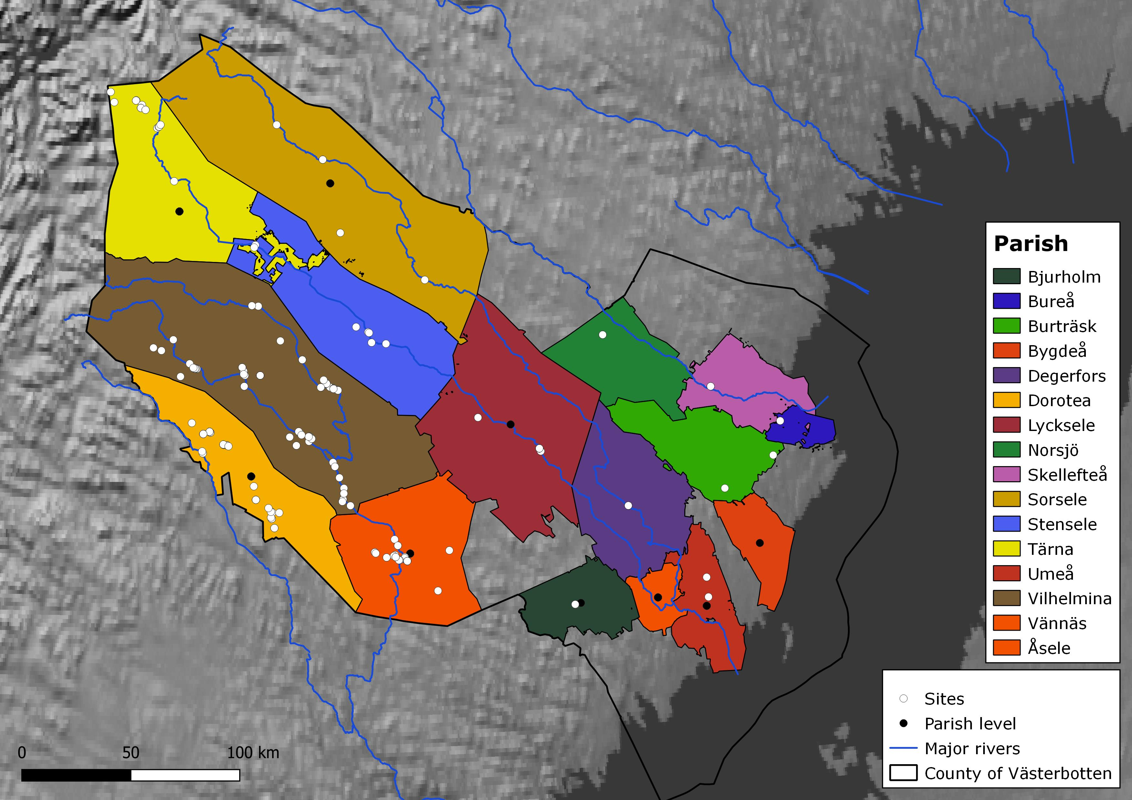

Figure 2.1: White) Sites with measured samples in the County of Västerbotten; Black) Parish centroid for measured samples lacking site coordinates. The distribution of sampled sites is likely affected by the excavation and survey history of the region. Made with Lantmäteriet (CC0), Natural Earth, and Riksantikvarieämbetet.

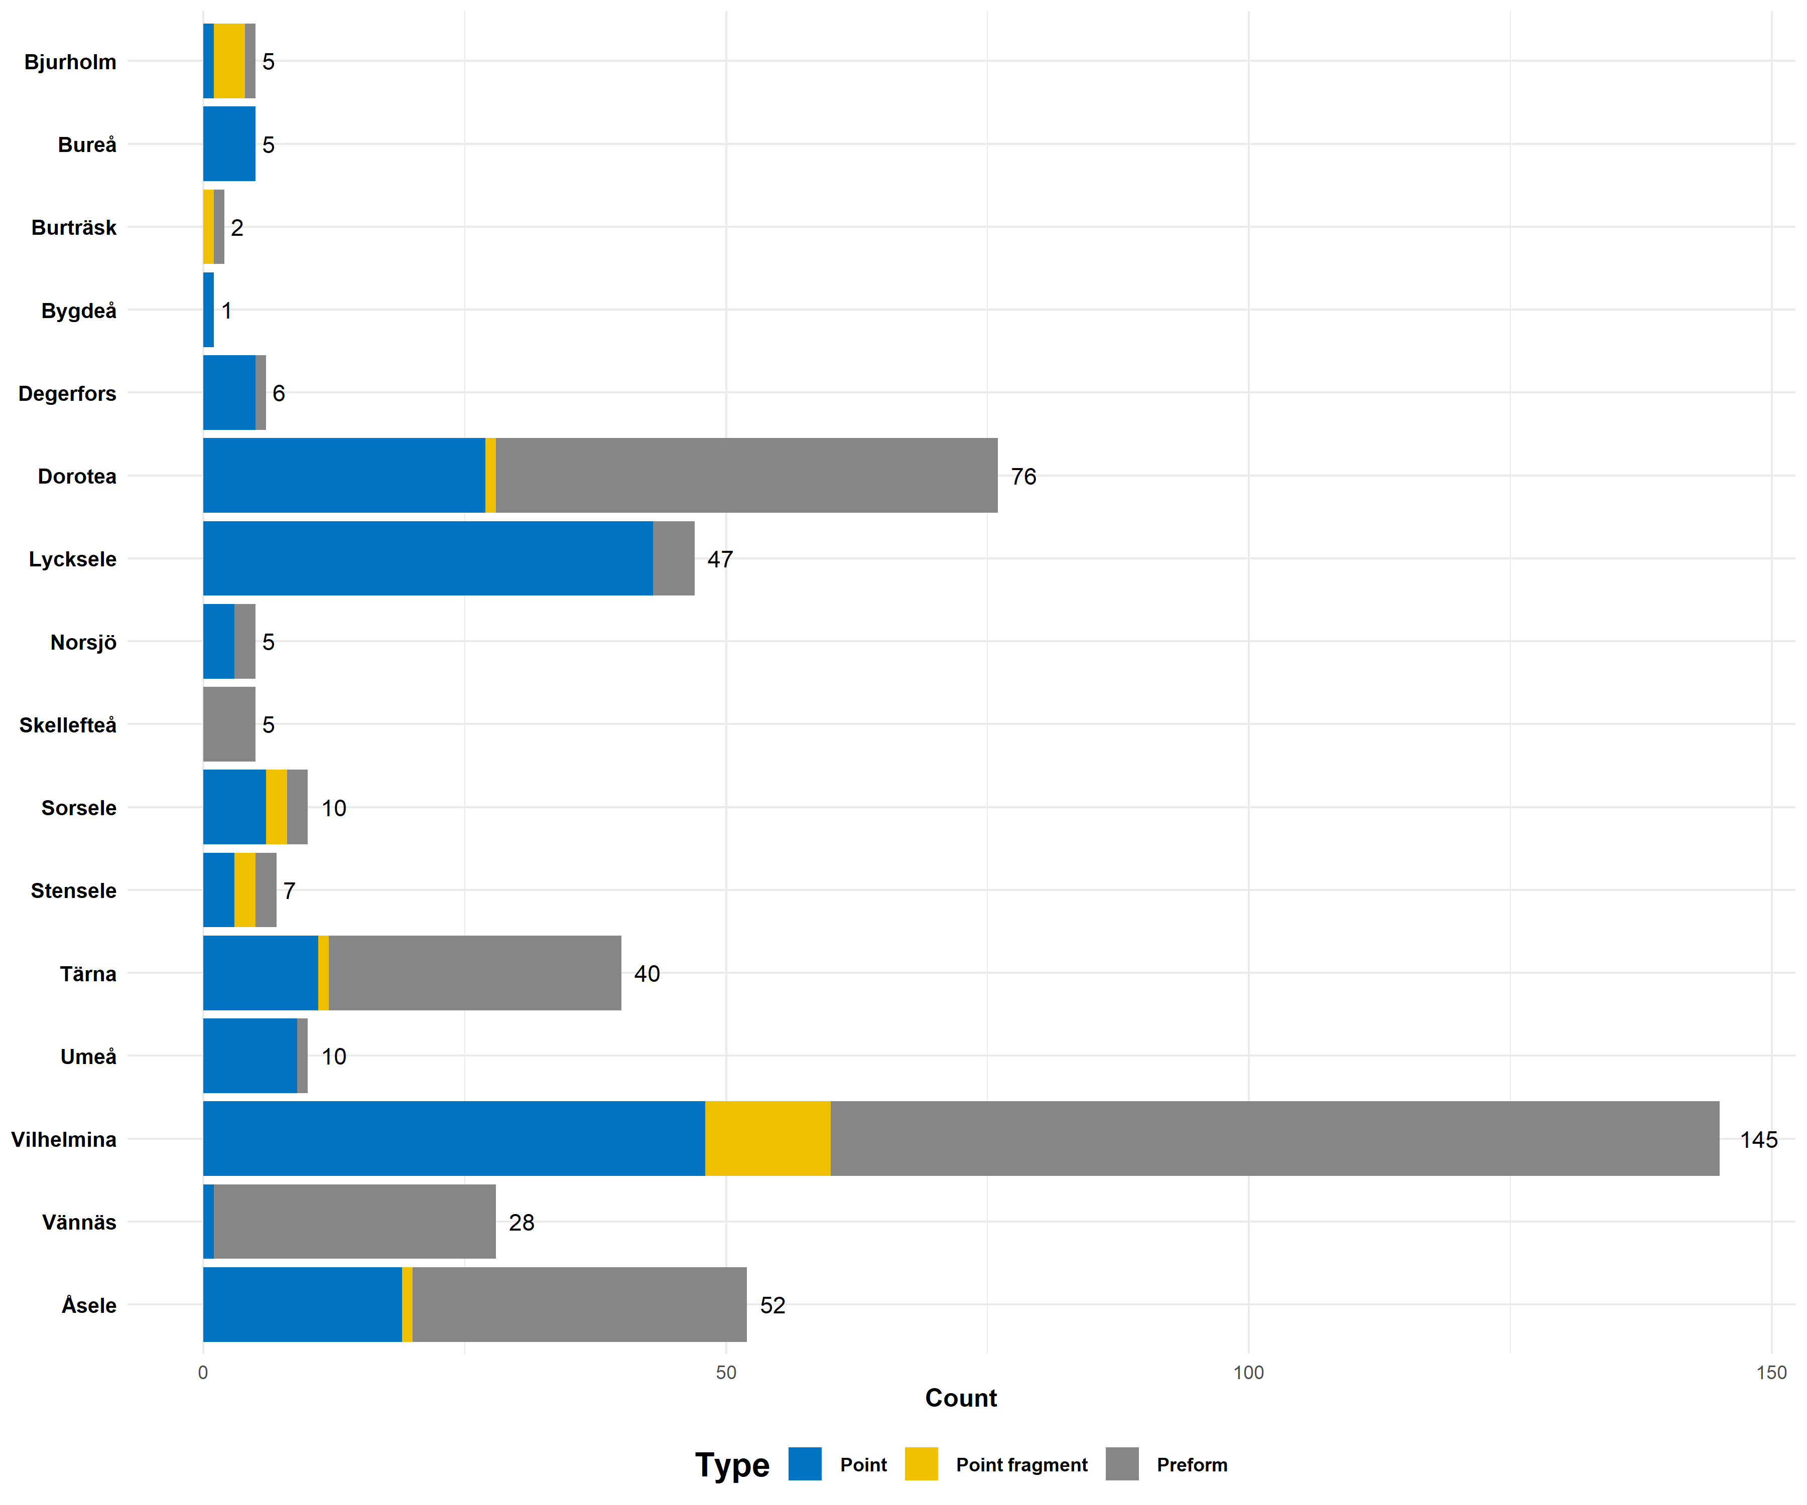

Figure 2.2: Distribution of the 444 points and preforms across the parishes in Västerbotten, Sweden. Note that while Lycksele feature a large number of samples 41 of these are from the site of Lycksele 301

While parts of the collections at Västerbotten museum have been petrographically analysed by a geologist (Åhman 1967; Biörnstad 1968), at this point it is difficult to say with any certainty how many (if any) of the artefacts in the current dataset were among these. It is fair to assume that the vast majority have been classified visually based on megascopic features according to a “standard” archaeological nomenclature. In the dataset the four main types of registered materials are: quartz, quartzite, brecciated quartz, and brecciated quartzite.[1] Those that had no prior material classification registered were sorted into either the quartz or quartzite category. The reason for including ‘quartz’ in the study is in order to test whether it is possible to separate quartz from quartzite using these methods, as well as a way to account for potential mistakes in the original classification.

Another reason for keeping a *quartz* category is the group referred to as *brecciated quartz*. In a petrographic study of the artefacts recovered along the Ume river valley Åhman (1967:8) briefly touches upon the definition of *brecciated quartz*, also referring to it as a *mylonite quartz*. Åhman describes the material as having formed from a quartz vein which has fractured due to movements in the mountain massives and recrystallized via pressure. While the translucent material may give the impression of an unusually pure quartzite, Åhman states that the thin-section analysis reveals the fragmented configuration of quartz. *Brecciated quartz* is a somewhat common term used in North Swedish archaeology, and has typically been used to identify a certain translucent type of fine-grained, quartz-rich material (e.g. Holm 1991).

# 3 Methods

All measurements were performed at the Environmental Archaeology Lab at Umeå University using three different instrumentations; NIRS, Raman scattering, and XRF. The analysis was conducted in a dark room in order to minimize light pollution, with the main light sources in the room being the computer screens. Each artefact was measured twice on different sides, with additional measurements in cases where sampling was difficult. The only exception to this was the XRF, where due to time constraints one measurement was collected as a rule apart from a few exceptions. This lowers the statistical reliability of the XRF analysis and inferences of the results should be evaluated with this in mind. The size of the dataset alleviates some of these issues, as for the larger sites there are multiple objects that likely were made from the same material, however, for the smaller sites there still remains some uncertainties.  
Pre-processing of the spectra is different for each instrumentation and based on relevant literature. After pre-processing the data was modelled using PCA, which is an unsupervised exploratory technique for reducing the dimensionality of the dataset (Geladi and Linderholm, 2020). PCA modelling was performed using the Prediktera Evince software (www.prediktera.com), which uses the NIPALS algorithm (Bertils 2019, pp. 9–10).

## 3.1 Near Infrared

NIRS measures the absorbance of light within the near infrared region (780 nm – 2 500 nm) of the electromagnetic spectrum. Based on the theory of molecular vibration and excitation (Hunt 1977), by exposing a geological material to electromagnetic radiation it is possible to generate overtone vibrations which can be related to certain molecular groups. The most common group capable of generating these overtones is the OH group, which in quartz-based materials typically relates to molecular water (REF). NIR analysis was conducted with the Analytical Spectral Device (ASD) LabSpec 4, using a contact probe. The ASD features a detection range of 350 – 2500 nm, with spectral sampling (resp. spectral resolution) of 1.4 nm (resp. 3 nm) in the visible and near infrared range and 1.1 nm (resp. 10 nm) in the short‐wave infrared range. Each object was measured against a white reference background. Two parts of the NIR spectra was analysed separately, the visual region (400 – 750 nm) and the 1 000 – 2 500 nm region. In both analyses the data was mean-centred before PCA modelling.

## 3.2 Raman

Raman spectroscopy shares some similarities with NIRS in that they both can be used to infer molecular structure based on their vibrational properties (Nafie 2001). However, where NIRS generate overtones of molecular vibration, Raman spectroscopy is based on the *Raman scattering* effect. By exposing a molecule to radiation with a monochromatic laser it is possible to induce a dipole moment in the molecule which generates the Raman effect. The subsequent light that is scattered contains both Rayleigh scatter and Raman scatter, the former at a frequency of incident radiation and the latter at a shifted frequency (Dubessy 2012). The spectrometer will measure the Raman scatter and generate a spectrum where the spectral line has shifted compared to the incident Rayleigh frequency. As the structure of a molecule will inform its vibrational mode, the point at which these shifts occur within the infrared region varies depending on the material (Smith and Carabatos-Nédelec 2001). The Raman instrumentation used was a portable i-Raman EX featuring a 1064 nm excitation laser. The spectral coverage of the instrumentation is 175 – 2 500 cm-1[2] with a resolution of 9.5 cm-1. Access to the spectrometer was made possible by the department of Forest Biomaterials and Technology at the Swedish University of Agricultural Sciences (SLU) in Umeå. All Raman spectra were baseline corrected using modified polynomial fitting in R (Team 2017) using the ChemoSpec package (Hanson 2016). The spectra were then mean-centred and normalized using Standard Normal Variate (Shaver 2001, pp. 284–285) in the Prediktera Evince software.

## 3.3 X-Ray Fluourescence

XRF measurements were collected using a Thermo Scientific Niton XL5 Analyzer, connected to a Thermo ScientificTM portable test stand. The reference calibration used for element quantification was *mining*. Sampling with this setting takes 2 minutes in order for the instrument to cycle through all of the filters (main, low, high, light). Due to time constraints and the number of objects in the current dataset it was only possible to collect one measurement on each object, apart from some exceptions. For materials that featured high heterogeneity the sample point was focused, as much as possible, on the surrounding matrix. The XRF data was pre-processed using mean-centering, univariate scaling, and log-transformation in the Prediktera Evince software before PCA modelling.

# 4 Results

## 4.1 NIR - visual range

The main explanatory power for the visual region can be found in the first two components, featuring eigenvalues above 1 with a cumulative explained variance of 99.9 %. Plotting these in the score plot there is a clear trend along the first component with darker materials being grouped together to the right of the plot and light/white material to the left (fig. 4.1). Average spectra of these groups demonstrate a higher absorbance for the dark group, with both of the light groups featuring higher absorbance in the violet region (fig. 4.2). Despite this trend there are exceptions, and while some of these may be material that exist within the muddled greyscale, there are measurements on dark surfaces (N1-N2) that end up closer to the light group (fig.X). There are also instances where the measurements on different sides of an artefact end up in different groups in the PCA. Artefact 403 and 502 both have a sample taken on one side in the ‘dark’ group and the other in the ‘greyish’ middle. This is most likely due to the heterogeneous character of the material and natural variations on the surface possibly related to weathering. The ‘greyish’ middle group is largely made up of ‘quartz coloured’ opaque material with a beige/grey tint (fig.X).

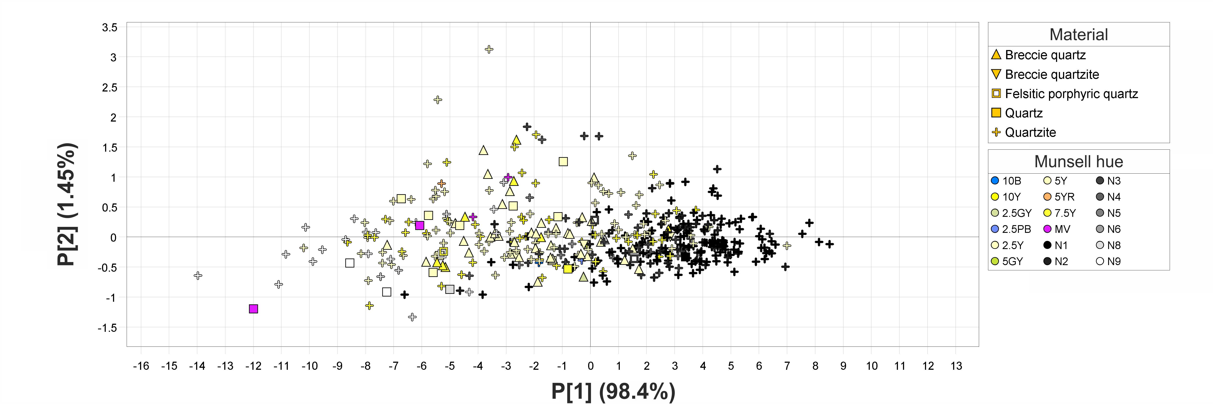

Figure 4.1: PCA score plot of 1st and 2nd components for the 400 nm – 750 nm region of the spectrum. Quartzite with a darker surface group to the right in the model, while white objects group in the bottom left quadrant.

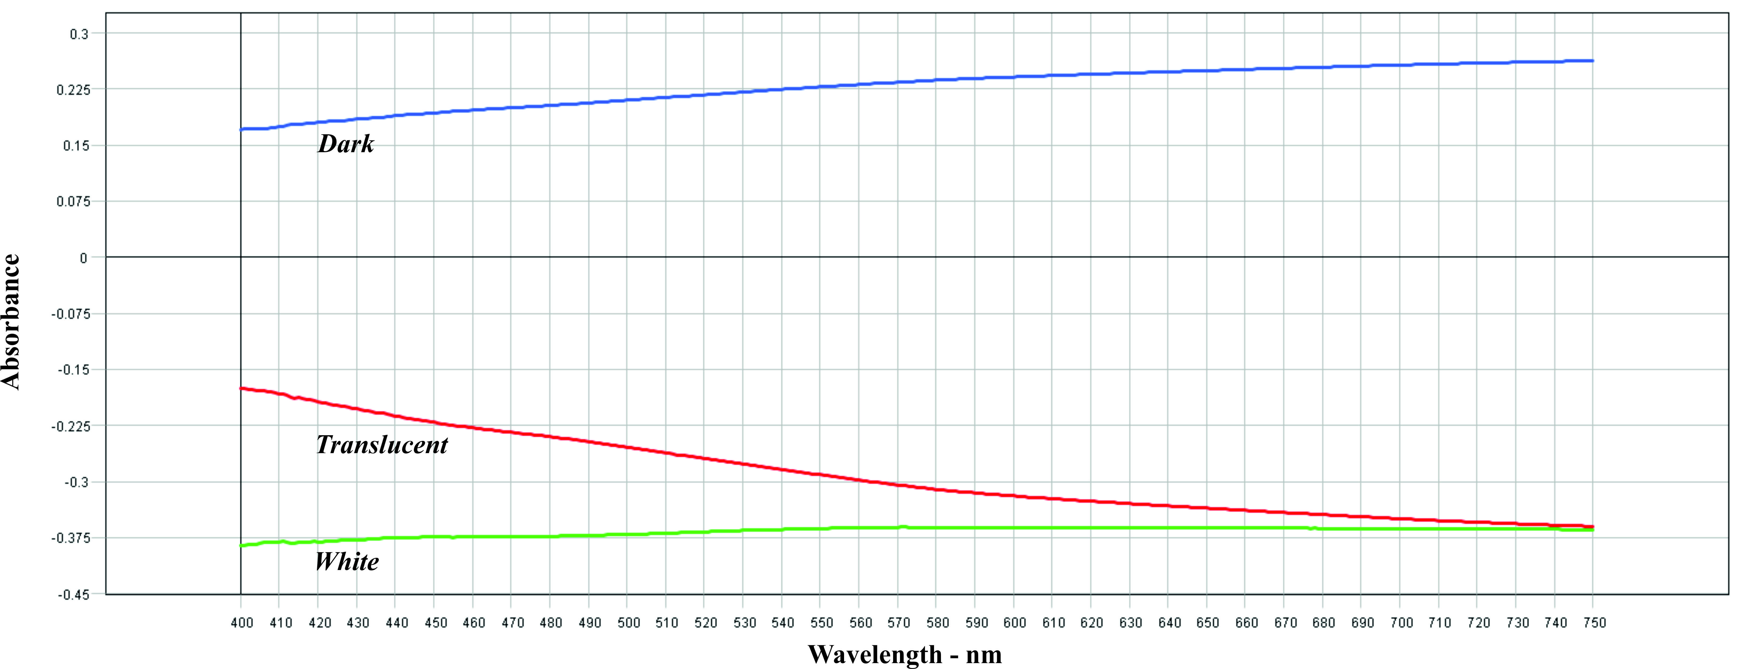

Figure 4.2: Average spectra for dark and light groups in the 400 - 750 nm region. Dark material has a higher overall absorbance, with material closer to a white hue feature lower absorbance. The *translucent*/*opaque* group also feature higher absorbance in the ultraviolet region.

## 4.2 NIR - near infrared range

No distinct peaks occurred in the 600 – 1 000 nm region, and thus the analysis focused on the 1 000 – 2 500 nm region to lessen the impact of noise. The PCA demonstrates a similar pattern to the one observed in the visual region (fig. 4.4). Again the first two components have an eigenvalue above 1 with cumulative explained variance of ~99.9 %. While the darker materials remain closely grouped in the right side of the score plot, the *light* cluster seems to split into two separate groups. The upper left group houses the main bulk of the *brecciated quartz*, as well as the almost translucent and opaque material with a beige tint. The bottom left group instead features the majority of the white *quartz-coloured* material. In the case of NIRS most features relate to the presence of molecular water in the material (Hunt 1977; Sciuto et al. 2019), these mainly occur at around 1 400 nm and 1 900 nm. In some of the measurements peaks also occur at 2 200 nm and 2 350 nm, where the former can be related to combination vibrations of Al-OH and the latter possibly CO3 (Clark et al. 1990). The average spectra for the three groups show that the *dark* group has the highest absorbance with less distinct peaks, although they are noticeable. The absorbance in the *brecciated*/*translucent* group is slightly higher in the lower band regions than compared to the *white* group, but with decreased absorbance in the higher regions. While a fifth peak at 2 450 nm can be difficult to discern in most cases, the average spectra for both the *brecciated*/*translucent* group and *white* group feature the above mentioned four peaks.

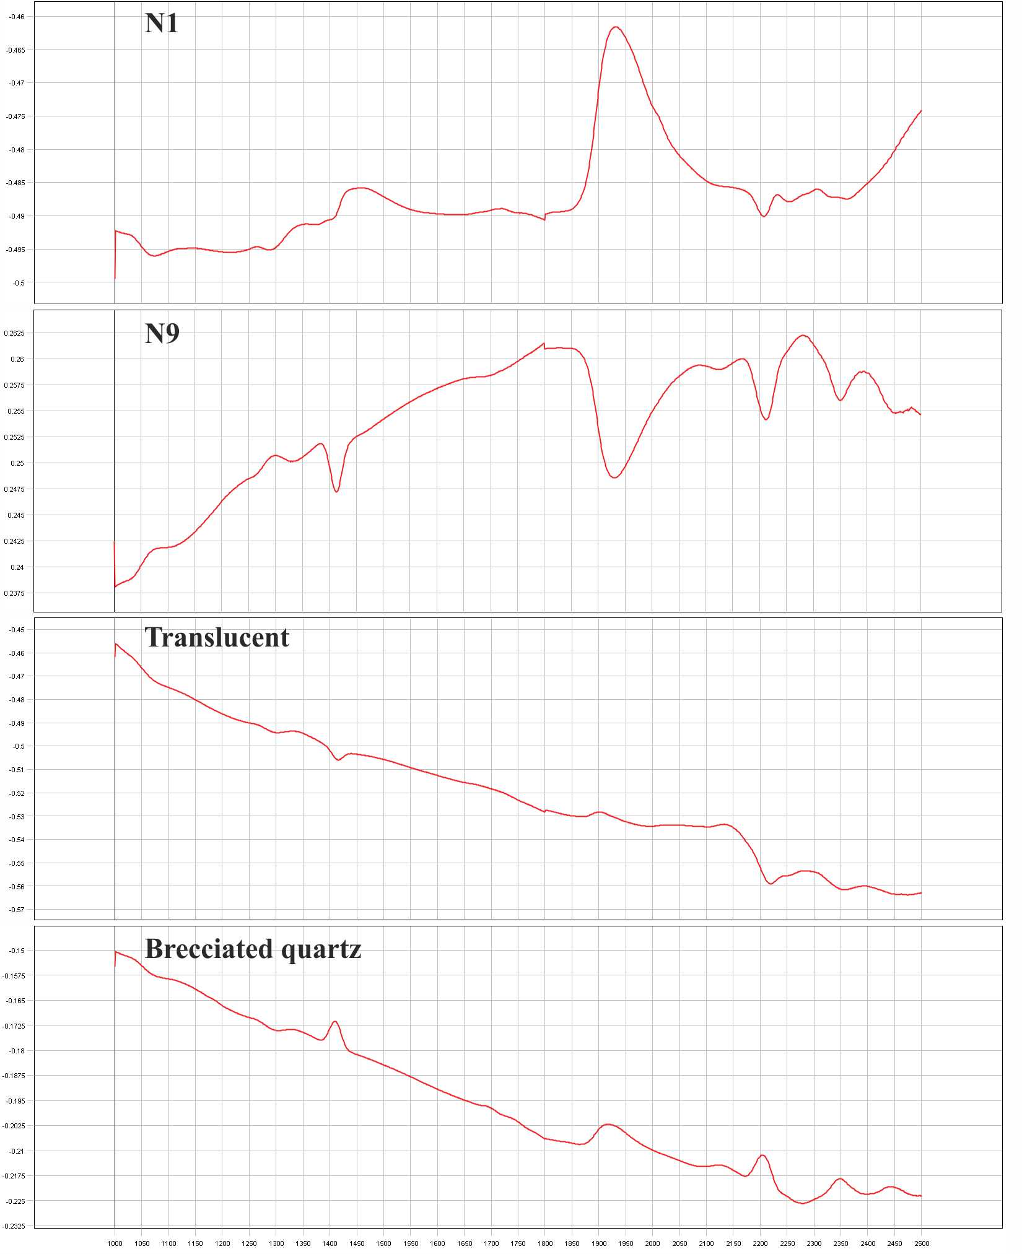

Figure 4.3: Comparison of average spectra for dark, white, and translucent materials. Brecciated quartz is included as it is typically translucent with dark particle inclusion, as a comparison with the translucent group that mainly is made up of seemingly pure quarts.

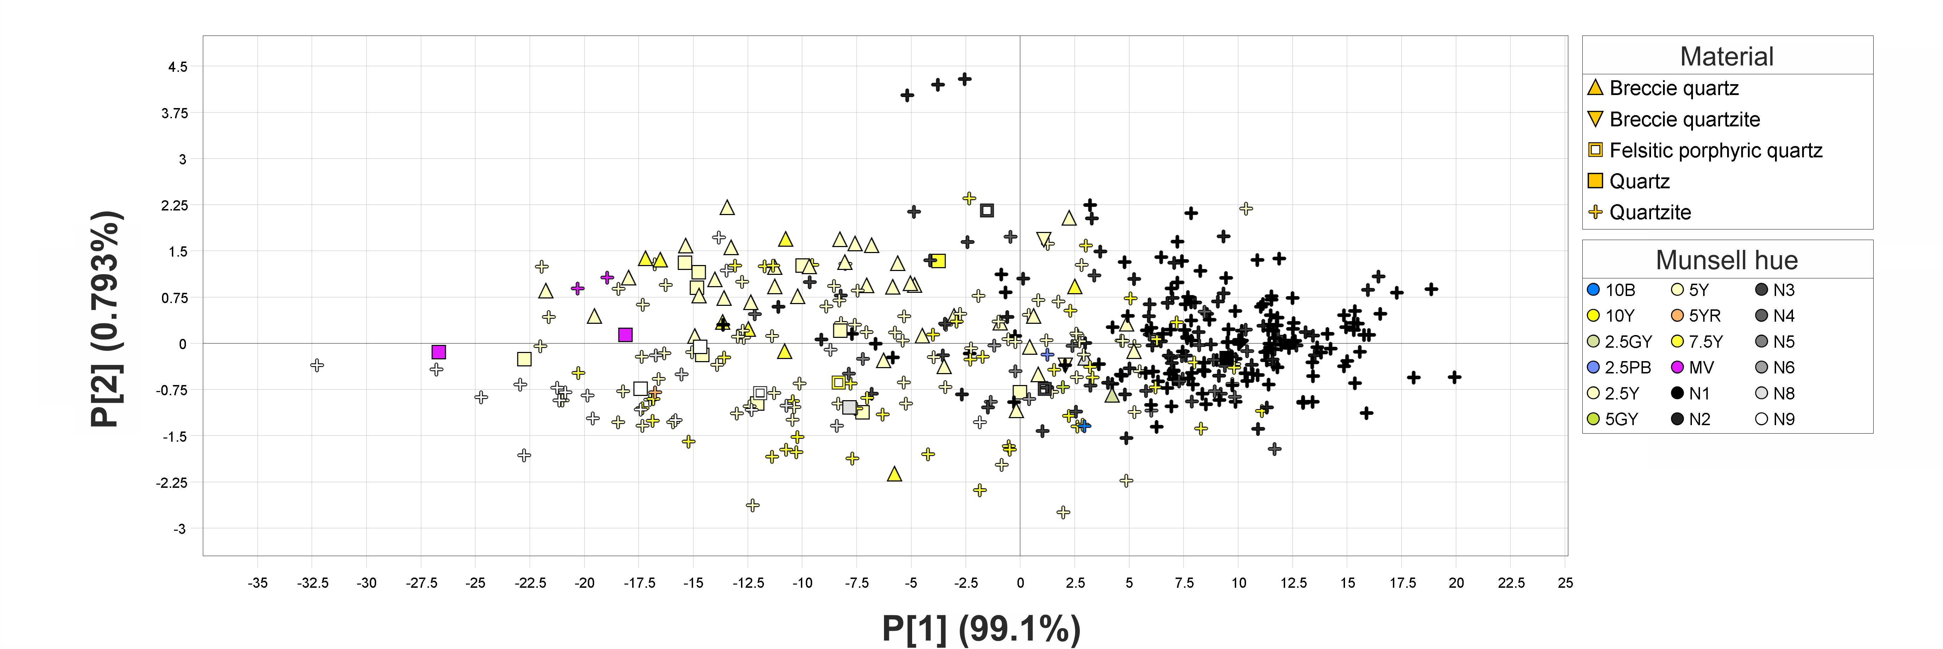

Figure 4.4: PCA score plot of 1st and 2nd components for the 1 000 nm – 2 500 nm region of the spectrum. Quartz-based material with a darker surface group to the right in the model, while those with white surface group in the bottom left quadrant. A trend of translucent material and opaque material with a beige tint grouping in the top left can also be seen.

## 4.3 Raman

There are two distinctive features present in the Raman data. The first can be identified as the *quartz* peak occurring at 460 cm-1 (Gillet et al. 1990), which is present for all samples in the dataset. The second feature shows up as two peaks occurring at around 1 300 cm-1 and 1 600 cm-1, and dominate the spectra in terms of intensity for the darker samples. These peak positions fall within what is referred to as the D and G band respectively, and have been observed in spectroscopic studies of graphite/graphene (Cesare and Maineri 1999). The D band occurs as a result of disordered carbon structures whilst the G band is indicative of sp2 carbon networks and caused by stretching in the carbon bonds, which is common in graphite-based materials (Vollebregt et al. 2012; Lee et al. 2021). Whereas the 2nd peak falls within the typical position of the G band, the 1st peak is positioned at 1 285 cm-1 which is in contrast with the usual position of the D band at 1 330 - 1 350 cm-1. One explanation for this could be frequency change as a result of the dispersive behavior of the D band (Pimenta et al. 2007, p. 1280).

The PCA model (fig.X) shows a clear trend along the first component (75.9 %) related to the above two features. The measurements with mainly quartz peaks gravitate towards the positive side of the 1st component, and those where the graphite peaks are dominant towards the opposite side. It is also clear that the darker material feature more pronounced graphite peaks, whereas the lighter and more translucent objects mainly feature quartz peaks. As in the case of the NIR data, however, there are exceptions that break this trend, as well as a “muddled” middle group with both well-pronounced graphite and quartz peaks. The 2nd component (7.82 %) mainly seems to differentiate the measurements that feature a lot of noise and objects that were difficult to sample. The same is true for the 3rd component, although it does not seem to be as susceptible to noise as the 2nd component. The 3rd component also separates out samples with irregular readings that could possibly be related to sampling issues on surfaces that were difficult to sample.

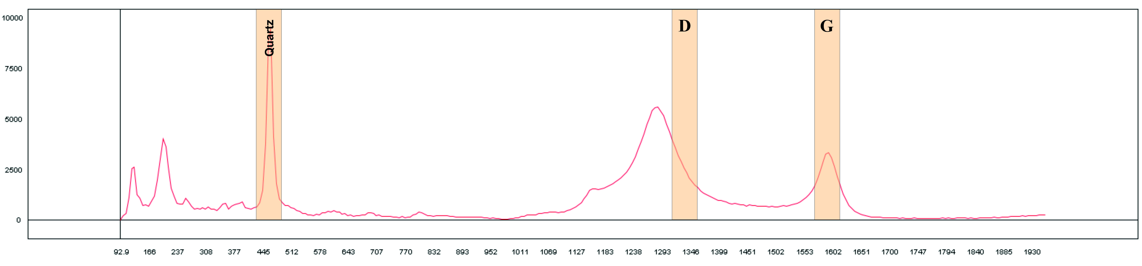

Figure 4.5: Average spectra of raman measurements sampled on grey-to-dark quartzite featuring both the *quartz peak* at 460 cm-1, as well as the possible *graphite peaks* around 1 300 cm-1 (D band) and 1 600 cm-1 (G band)



Figure 4.6: PCA score plot of 1st and 2nd components of the raman analysis. The materials group based on two main features, the quartz-peak at 460 cm-1 and the D/G band peaks around 1300 cm-1 and 1600 cm-1. Darker materials feature more pronounced D/G band peaks while the white and more translucent materials feature only the quartz peak.

## 4.4 XRF

The XRF spectrometer is not capable of detecting all of the common elements, and the software therefore calculates a balance (Bal), which represents the remaining unquantifiable elements in a sample. The elements represented in this unquantifiable group are all those with an atomic number lower than 12Mg (REF). Univariate analysis shows that SiO2 makes up the main bulk of the composition of the material, and two major groups can be distinguished based on this content (fig. 4.7). The majority of the readings resulted in a SiO2 content of less than 50%, and about ¼ of the readings (~ 27%) featured a SiO2 content closer to 90 %. The “low” SiO2 group also feature a Bal between 40 – 70 %.

The three first components of the PCA have an eigenvalue above 1 and the cumulative explained variance is ~ 86.5%. The loadings of the three components can be seen in figure 4.8. In the score plot of P1 and P2, two large clusters emerges (fig. 4.9). The loadings for 13Al, 18Sr, 19K, 20Ca, 40Zr, 81Ti group together in the top right quadrant whilst 12Mg, 14Si, 15P, 16S, 23V, and 56Ba group in the bottom right. As seen in figure 4.9, 26Fe is the only element positioned on the left side of the model. Interestingly, the left cluster contains the samples with lower 14Si values and the right cluster the higher values. These clusters still remain if you were to exclude 14Si from the model, however, suggesting there are other elements of relevance to the clustering. The “low 14Si” cluster shows a trend along P2 of quartzite with a darker hue grouping towards the top. This may indicate a possible relation to the 26Fe content of the material, as a darker hue may be the result of inclusions of hematite, or possibly biotite. 13Al follows a similar trend with higher values recorded at the top of the two clusters. The *brecciated quartz* samples largely group together at the bottom of the “low 14Si” cluster, with a couple ending up towards the bottom of the “high 14Si” cluster. The white (N9) material is somewhat evenly distributed within the leftmost cluster. The group of measurements that are somewhat separated from the “low 14Si” cluster at the top are all but one from the rock painting site of *Finnforsberget*, which is located next to the Skellefte river. The *Finnforsberget* artefacts were sampled twice with object 491 having one measurement closer to the “low 14Si” group and the other the “high 14Si” group with 13Al estimated at 25 %. This artefact was sampled twice on each side, resulting in similar results both times. One almost translucent sample also ends up among the darker material. Upon closer inspection this sample is extremely small, 3 by 1 mm, and also feature inclusions of dark particles. Both of these factors may have contributed to its placement in the model.

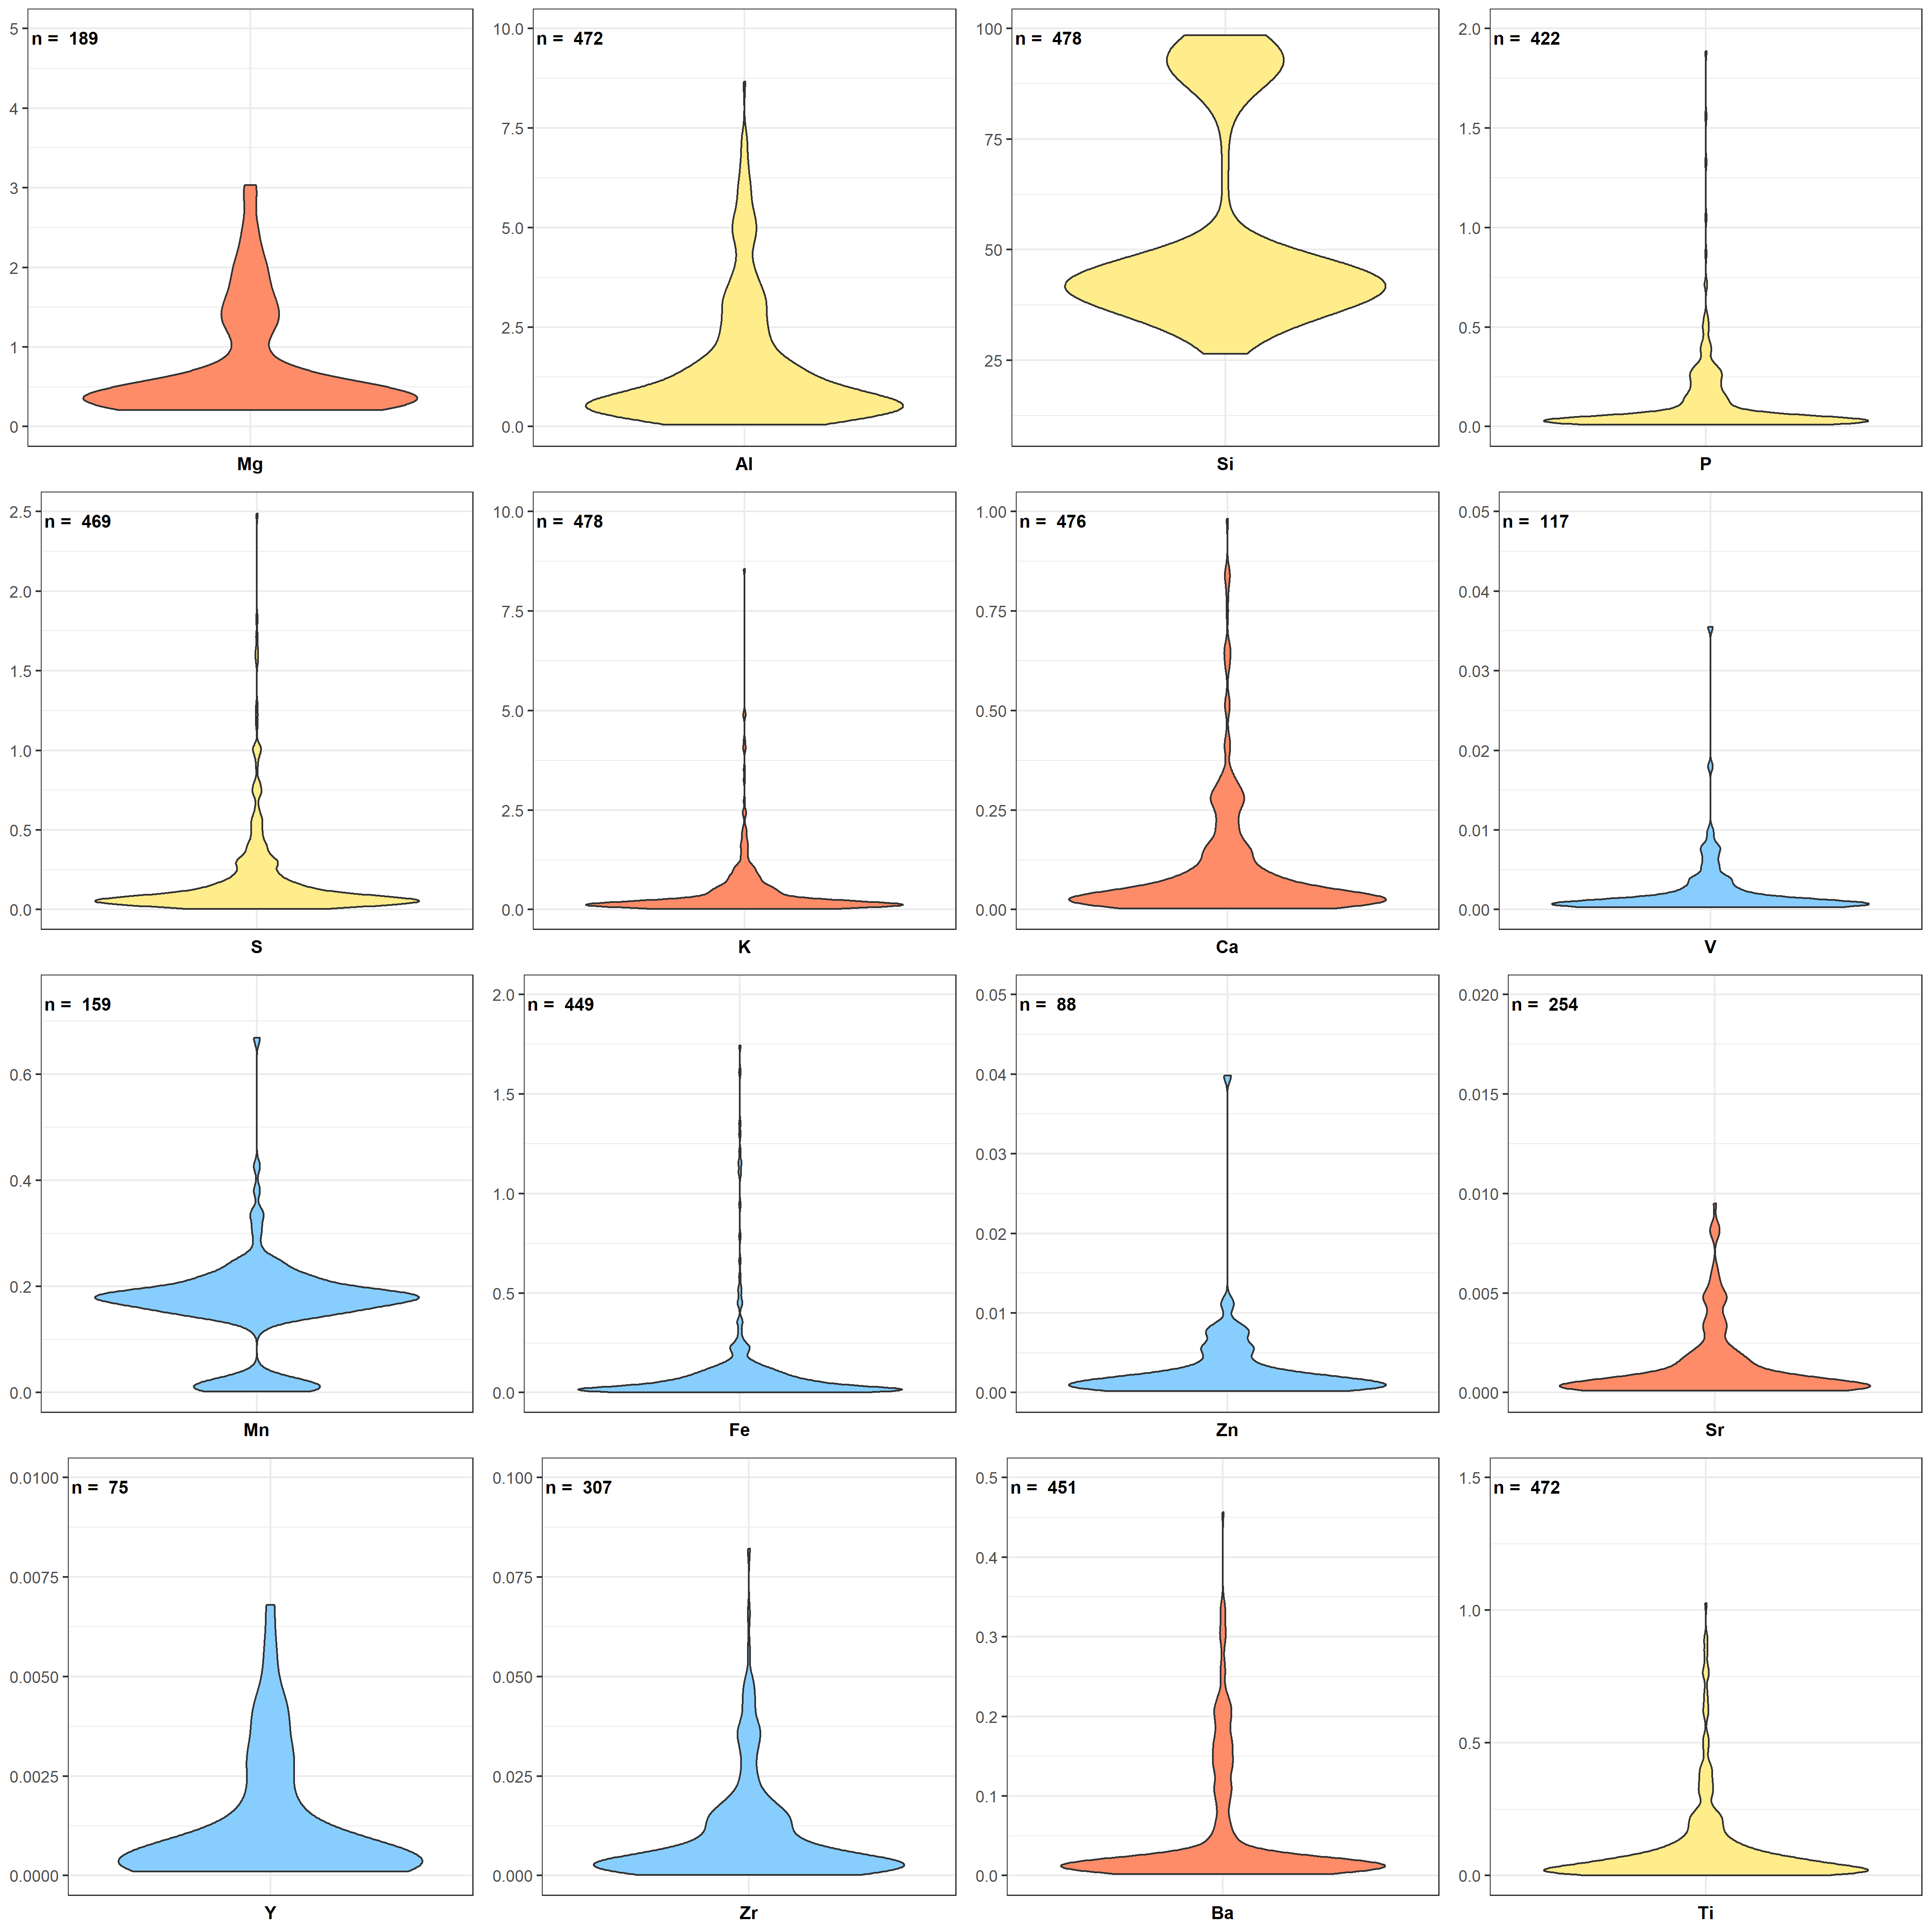

Figure 4.7: Violin plot of element content in quartzite samples measured using pXRF. **n** represents no. of measurements above Limit of Detection (LOD) for that element out of a total of 478 measurements. Note the bimodal distribution of Si measurements, these groups are reflected in the score plot of the PCA

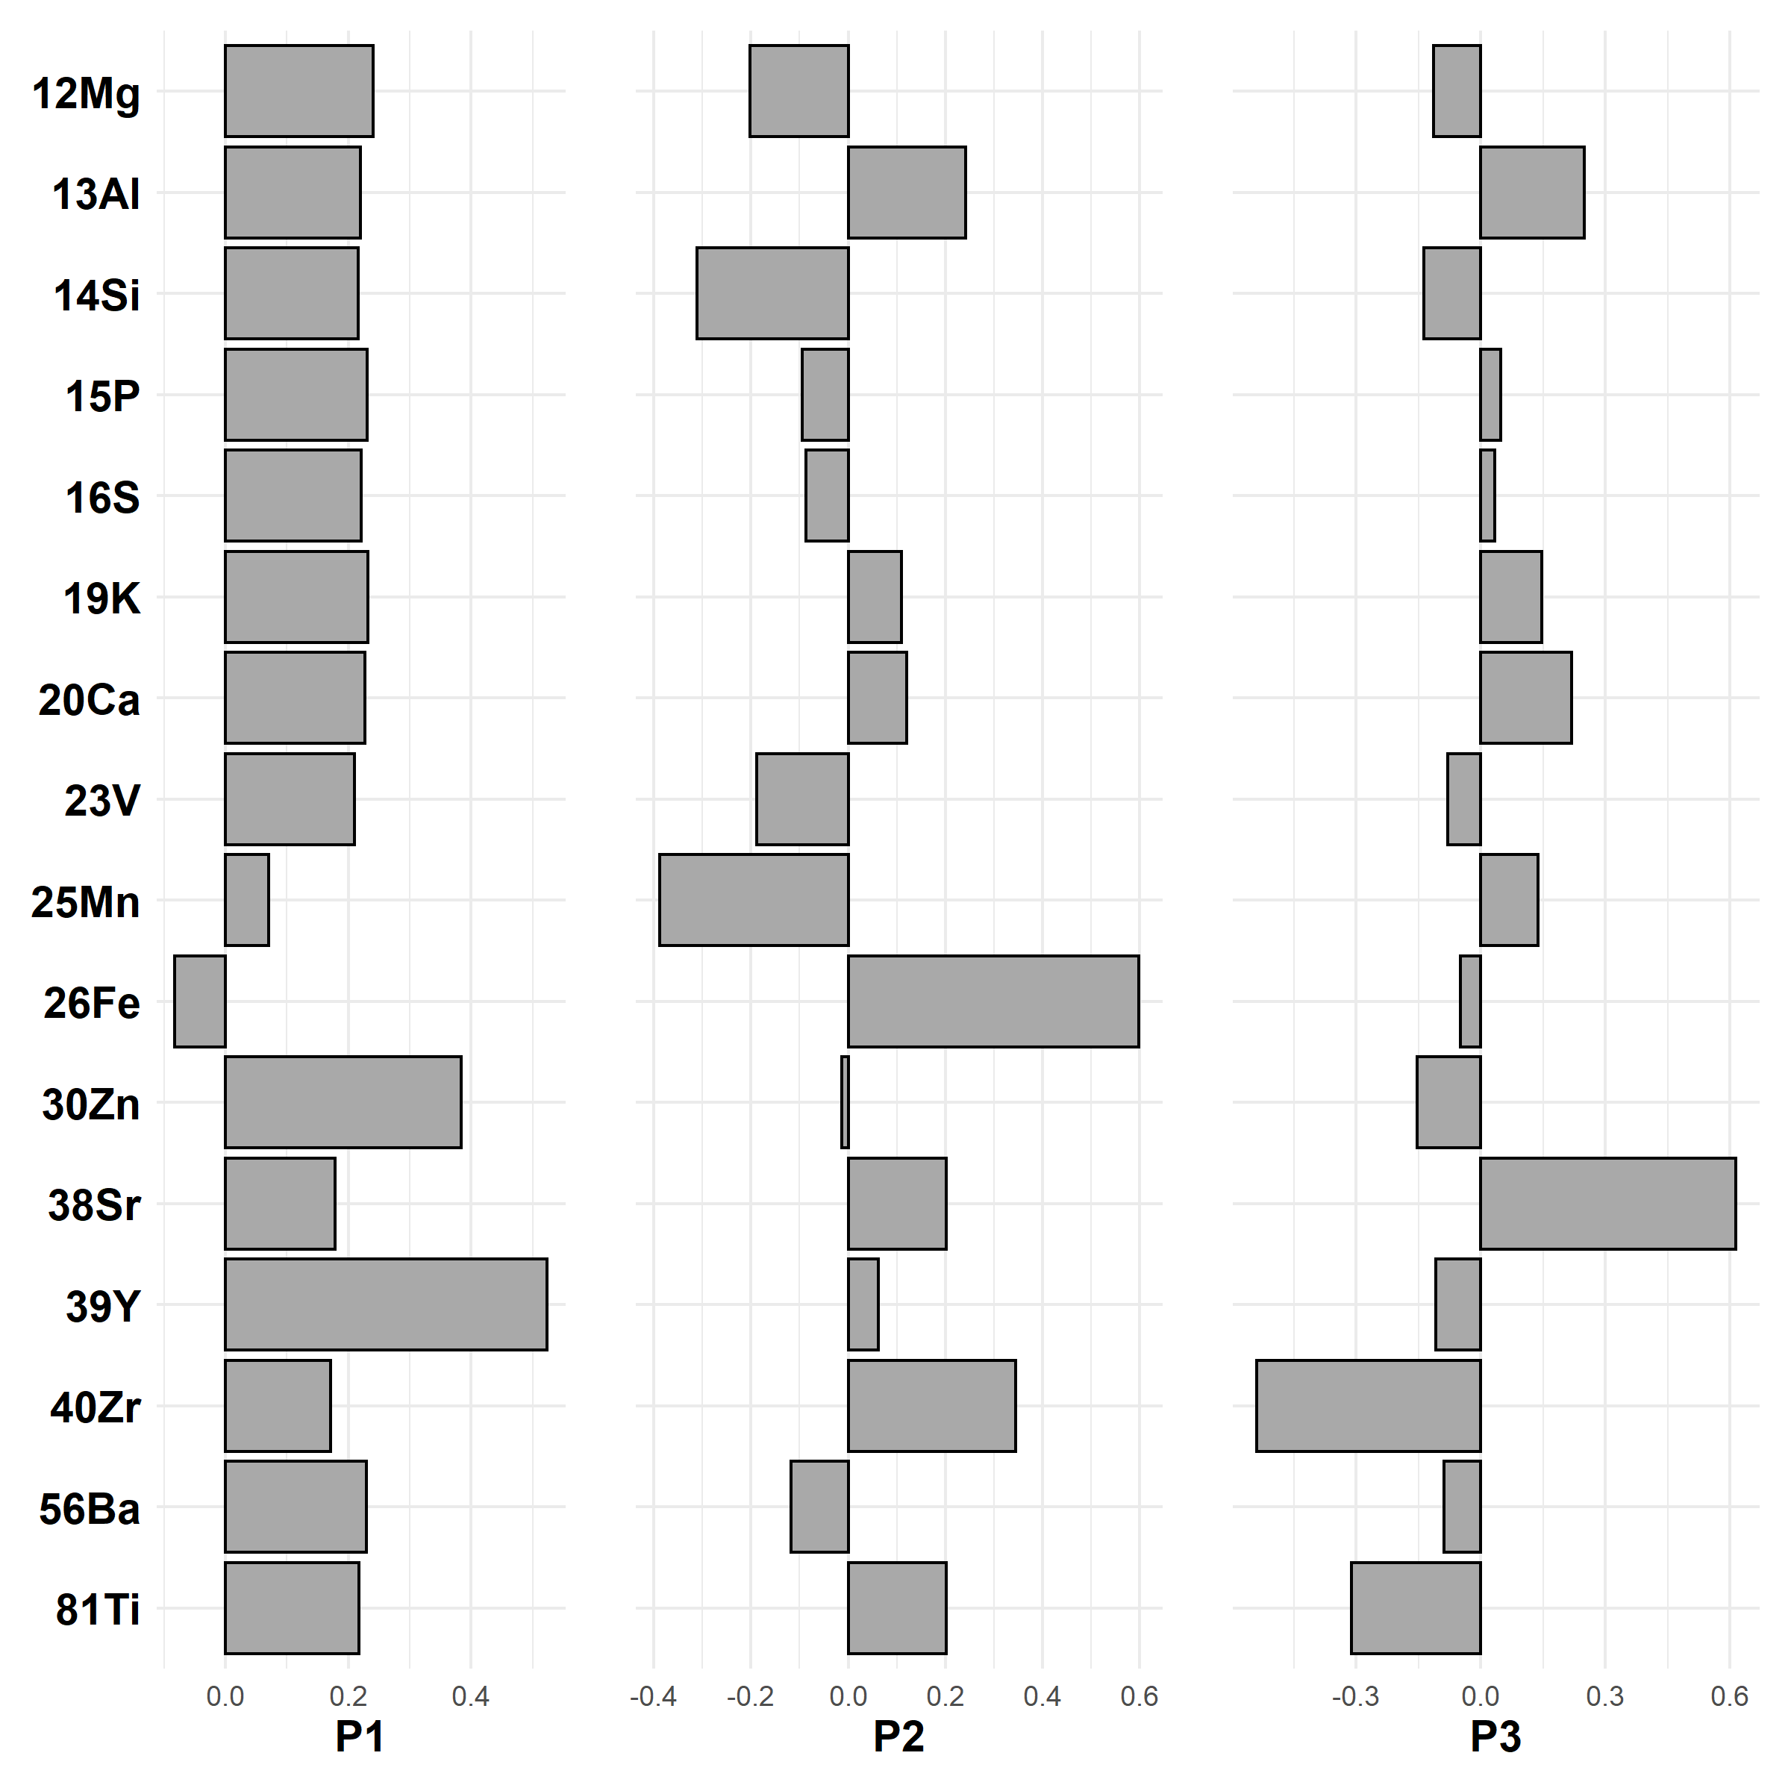

Figure 4.8: The three first loading vectors (P1-P3) with scores for each loading (element)

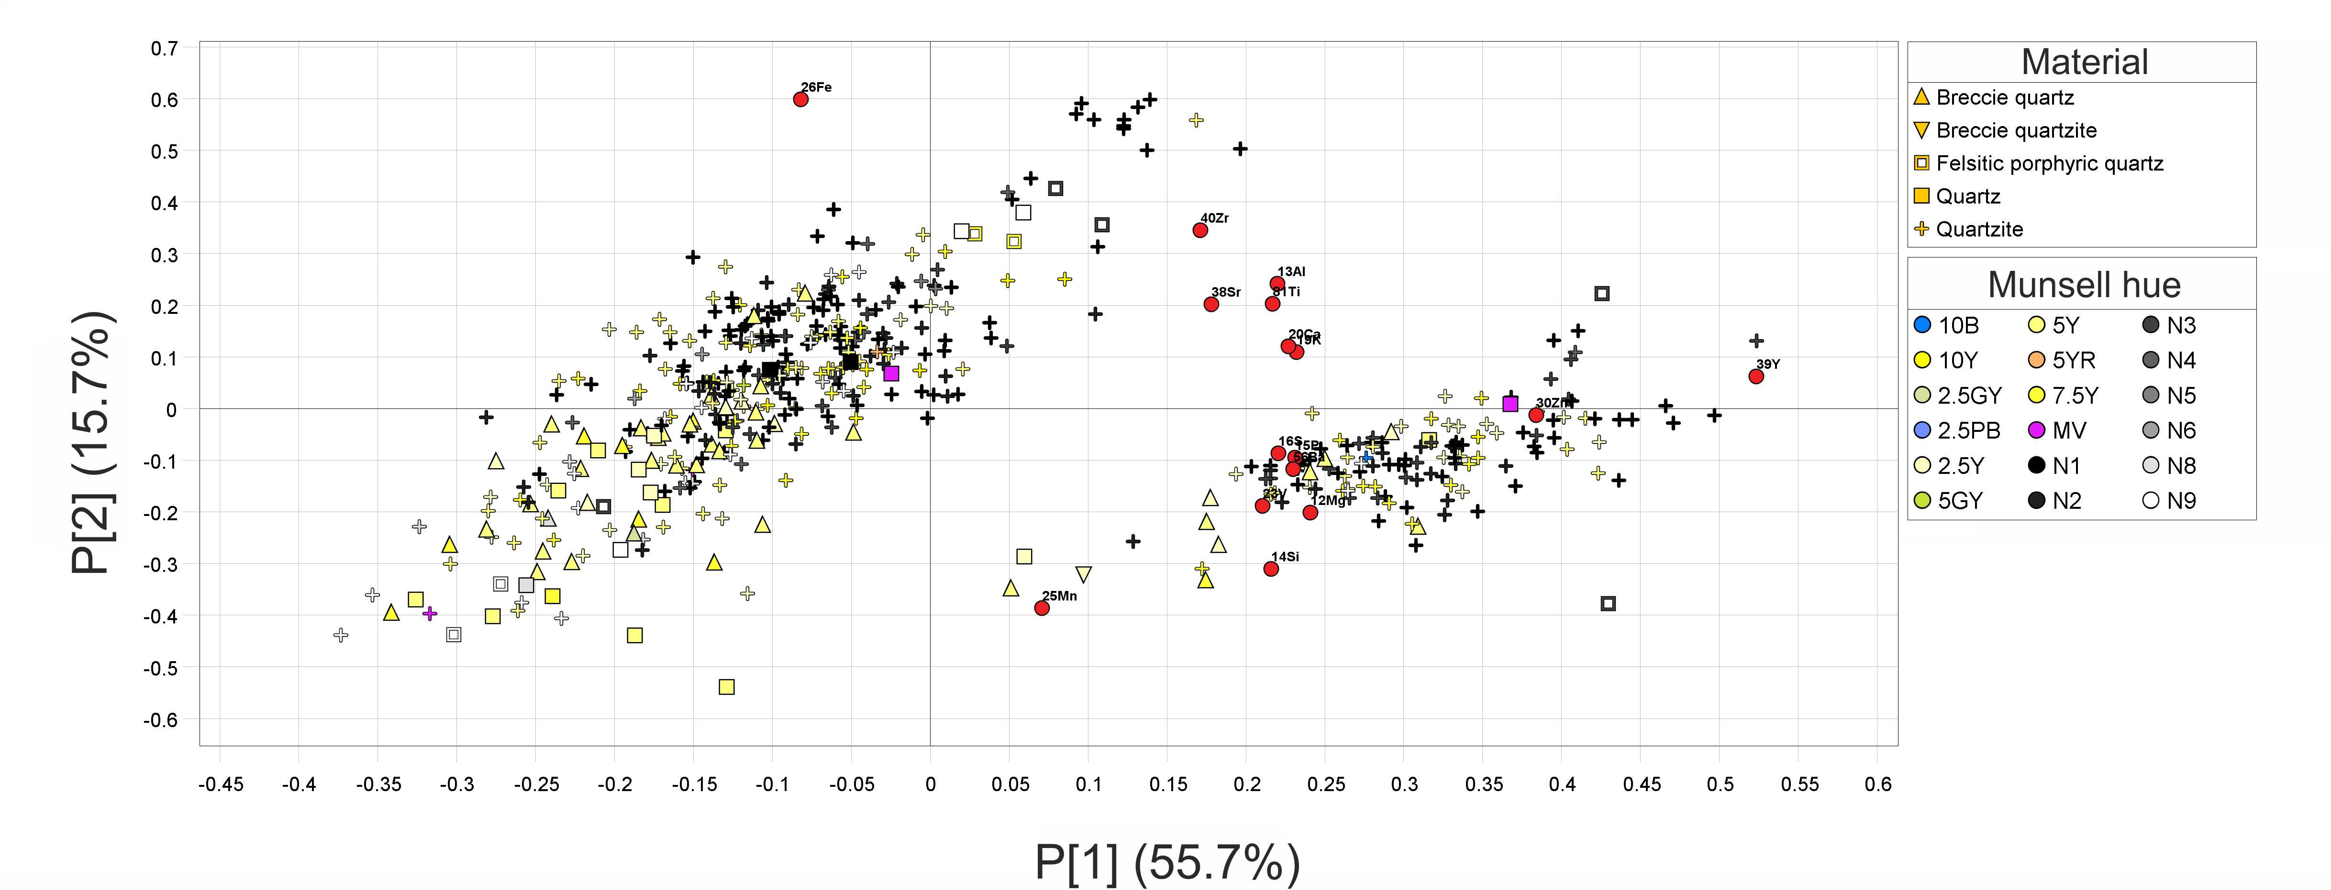

Figure 4.9: Score plot for P1 and P2, the two major groups are distinguished by lower SiO content to the left and higher to the right

# 5 Discussion

The results demonstrate clearly that all three instrumentations are capable of characterizing some aspect of the quartz and quartzite, however, none of them are capable of providing a detailed fingerprint on their own based solely on surface measurements. Taken together they do provide a more in-depth understanding of the characteristic and structure of the material. The most easily recognizable megascopic feature of the material is its colour, and the results of all three instrumentations demonstrate that there is some truth to this. However, a large group of the material, which features different hues of grey, does not conform as easily. In each of the PCA models there is a *greyish* middle that makes classification difficult.

Interestingly the ‘brecciated quartz’ remains relatively grouped together in all of the models demonstrating some consistency in the original classification. There are exceptions, however, and it would be advisable to follow up with a more directed analysis focused around this group of material……

# 6 Conclusion

# 7 Acknowledgements

# 8 References

Andersson B (2015) Sammanställning av projektet Arkeologiska undersökningar vid reglerade sjöar och vattendrag. Västerbottens museum, Umeå

Åhman E (1967) Riksantikvarieämbetets norrlandsundersökningar 4. Petrografisk översikt av Umeälvsmaterialet. Fornvännen 8–11

Bargel TH (2003) Quaternary geological Mapping of Fennoscandia and Nordland: Deglaciation, Deposits, Stratigraphy, and Applications. Norges teknisk-naturvitenskapelige universitet

Baudou E (1978) Kronologi och kulturutveckling i mellersta Norrland under stenåldern och bronsåldern. In: Huggert A (ed) Studier i Norrländsk forntid. Västerbottens museum, Umeå

Bertils J (2019) Implementation of Principal Component Analysis For Use in Anomaly Detection Using CUDA. Student thesis

Biörnstad M (2006) Kulturminnesvård och vattenkraft 1942-1980: En studie med utgångspunkt från Riksantikvarieämbetets sjöregleringsundersökningar. Kungl. Vitterhets historie och antikvitets akademien, Stockholm

Biörnstad M (1968) Forskningsprojektet Norrlands tidiga bebyggelse. Fornvännen 178–185

Blomme A, Degryse P, Van Peer P, Elsen J (2012) The characterization of sedimentary quartzite artefacts from Mesolithic sites, Belgium. Geologica Belgica 15:193–199

Broadbent N (1979) Coastal resources and settlement stability : A critical study of a Mesolithic site complex in northern Sweden. Institutionen för arkeologi, särskilt nordeuropeisk, Uppsala

Callahan E, Forsberg L, Knutsson K, Lindgren C (1992) Frakturbilder.: Kulturhistoriska kommentarer till kvarts säregna sönderfall vid bearbetning. Tor 25:27–63

Cesare B, Maineri C (1999) Fluid-present anatexis of metapelites at El Joyazo (SE Spain): Constraints from Raman spectroscopy of graphite. Contributions to mineralogy and petrology 135:41–52. <https://doi.org/10.1007/s004100050496>

Clark R, King T, Klejwa M et al (1990) High spectral resolution reflectance spectroscopy of minerals. Journal of Geophysical Research 95:12653–12680

Cnudde V, Dewanckele J, Kock TD et al (2012) Preliminary structural and chemical study of two quartzite varieties from the same geological formation: A first step in the sourcing of quartzites utilized during the Mesolithic in northwest Europe. Geologica Belgica 16:27–34

Dalpra CL, Pitblado BL (2016) Discriminating Quartzite Sources Petrographically in the Upper Gunnison Basin, Colorado: Implications for Paleoamerican Lithic-Procurement Studies. PaleoAmerica 2:22–31. <https://doi.org/10.1080/20555563.2015.1137684>

Dubessy J (2012) Applications of Raman spectroscopy to earth sciences and cultural heritage : University textbook. European Mineralogical Union, London

Forsberg L (1985) Site variability and settlement patterns: An analysis of the hunter-gatherer settlement system in the Lule River Valley, 1500 B.C.-B.C./A.D. Umeå University

Forsberg L (1989) Ett försök att urskilja sociala territorier i Norrland under bronsålder och förromersk järnålder. Regionale forhold i nordisk bronzealder: 5 Nordiske symposium for bronzealderforskning på Sandbjerg Slot 1987 169–173

Gillet P, Le Cléac’h A, Madon M (1990) High-temperature raman spectroscopy of SiO2 and GeO2 Polymorphs: Anharmonicity and thermodynamic properties at high-temperatures. Journal of Geophysical Research: Solid Earth 95:21635–21655. <https://doi.org/10.1029/JB095iB13p21635>

Hanson BA (2016) ChemoSpec: Exploratory Chemometrics for Spectroscopy

Holm L (1991) The use of stone and hunting of reindeer a study of stone tool manufacture and hunting of large mammals in the central Scandes c. 6000-1 BC. Dept. of Archaeology [Institutionen för arkeologi], Umeå University, Umeå

Howard JL (2005) The Quartzite Problem Revisited. The Journal of Geology 113:707–713. <https://doi.org/10.1086/449328>

Hunt GR (1977) Spectral signatures of particular minerals in the visible and near infrared. Geophysics 42:501–513

Janson S, Hvarfner H (1960) Från norrlandsälvar och fjällsjöar: Riksantikvarieämbetets kulturhistoriska undersökningar i samband med kraftverksbyggen och sjöregleringar. Riksantikvarieämbetet, Stockholm

Knutsson H, Knutsson K, Molin F, Zetterlund P (2016) From flint to quartz: Organization of lithic technology in relation to raw material availability during the pioneer process of Scandinavia. Quaternary International 424:32–57. <https://doi.org/10.1016/j.quaint.2015.10.062>

Lee AY, Yang K, Anh ND et al (2021) Raman study of D* band in graphene oxide and its correlation with reduction. Applied Surface Science 536:147990. <https://doi.org/10.1016/j.apsusc.2020.147990>

Linderholm J, Geladi P (2014a) Portable near infrared spectroscopy and imaging on archaeological sites and samples in the MOBIMA project. Part 1. Field spectroscopy. NIR news 25:11–15. <https://doi.org/10.1255/nirn.1457>

Linderholm J, Geladi P (2014b) Portable near infrared spectroscopy and imaging on archaeological sites and samples in the MOBIMA project. Part 2. The potential of hyperspectral field imaging. NIR news 25:8–12

Mjærum A (2012) The bifacial arrowheads in Southeast Norway. A chronological study. Acta Archaeologica 83:105–143

Nafie LA (2001) Theory of Raman Scattering. In: Lewis IR, Edwards HGM (eds) Handbook of raman spectroscopy : From the research laboratory to the process line. Marcel Dekker, New York, pp 1–10

Olausson D, Hughes RE, Högberg A (2012) PROVENANCE STUDIES ON SCANDINAVIAN FLINT. Acta Archaeologica 83:83–86. <https://doi.org/10.1111/j.1600-0390.2012.00576.x>

Pimenta MA, Dresselhaus G, Dresselhaus MS et al (2007) Studying disorder in graphite-based systems by Raman spectroscopy. Phys Chem Chem Phys 9:1276–1290. <https://doi.org/10.1039/B613962K>

Prieto A, Yusta I, Arrizabalaga A (2020) From petrographic analysis to stereomicroscopic characterisation: A geoarchaeological approach to identify quartzite artefacts in the Cantabrian Region. Archaeological and Anthropological Sciences 12:32. <https://doi.org/10.1007/s12520-019-00981-7>

Prieto A, Yusta I, Arrizabalaga A (2019) Defining and Characterizing Archaeological Quartzite: Sedimentary and Metamorphic Processes in the Lithic Assemblages of El Habario and El Arteu (Cantabrian Mountains, Northern Spain). Archaeometry 61:14–30. <https://doi.org/10.1111/arcm.12397>

Rankama T, Manninen MA, Hertell E, Tallavaara M (2006) Simple production and social strategies: Do they meet? Social dimensions in Eastern Fennoscandian quartz. In: Apel J, Knutsson K (eds) Skilled production and social reproduction : Aspects of traditional stone-tool technologies : Proceedings of a symposium in Uppsala, August 20-24, 2003. Societas archaeologica Upsaliensis, Uppsala

Sciuto C (2019) Carved Mountains and Moving Stones - Applications of Near Infrared Spectroscopy for Mineral Characterisation in Provenance Studies. Umeå University

Sciuto C, Geladi P, La Rosa L et al (2019) Hyperspectral Imaging for Characterization of Lithic Raw Materials: The Case of a Mesolithic Dwelling in Northern Sweden. Lithic Technology 44:22–35. <https://doi.org/10.1080/01977261.2018.1543105>

Shackley MS (2011) X-ray fluorescence spectrometry (XRF) in geoarchaeology. New York : Springer, New York

Shaver JM (2001) Chemometrics for Raman Spectroscopy. In: Lewis IR, Edwards HGM (eds) Handbook of raman spectroscopy: From the research laboratory to the process line. Marcel Dekker, New York

Smith DC, Carabatos-Nédelec C (2001) Raman Spectroscopy Applied to Crystals: Phenomena and Principles, Concepts and Conventions. In: Lewis IR, Edwards HGM (eds) Handbook of raman spectroscopy: From the research laboratory to the process line. Marcel Dekker, New York, pp 349–423

Stephens MB, Bergman Weihed J (2020) Sweden: Lithotectonic framework, tectonic evolution and mineral resources. The Geological Society of London, London

Stroeven AP, Hättestrand C, Kleman J et al (2016) Deglaciation of Fennoscandia. Quaternary Science Reviews 147:91–121. <https://doi.org/10.1016/j.quascirev.2015.09.016>

Tallavaara M, Manninen MA, Hertell E, Rankama T (2010) How flakes shatter: A critical evaluation of quartz fracture analysis. Journal of Archaeological Science 37:2442–2448. <https://doi.org/10.1016/j.jas.2010.05.005>

Team RC (2017) R: A language and environment for statistical computing.

Tykot RH (2003) Determining the source of lithic artifacts and reconstructing trade in the ancient world. In: Kardulias NP, Yerkes RW (eds) Written in stone: The multiple dimensions of lithic analysis. Lexington Books, Lanham, Md

Vandenabeele P (2012) Applications of Raman spectroscopy in cultural heritage research. In: Dubessy J, Caumon M, Rull F (eds) Raman spectroscopy applied to earth sciences and cultural heritage. European Mineralogical Union and Mineralogical Society of Great Britain & Ireland, London

Vollebregt S, Ishihara R, Tichelaar FD et al (2012) Influence of the growth temperature on the first and second-order Raman band ratios and widths of carbon nanotubes and fibers. Carbon 50:3542–3554. <https://doi.org/10.1016/j.carbon.2012.03.026>

### 8.0.1 Colophon

This report was generated on 2021-08-30 09:20:54 using the following computational environment and dependencies:

#> - Session info ---------------------------------------------------------------  
#> setting value   
#> version R version 4.0.4 (2021-02-15)  
#> os Windows 10 x64   
#> system x86_64, mingw32   
#> ui RTerm   
#> language (EN)   
#> collate Swedish_Sweden.1252   
#> ctype Swedish_Sweden.1252   
#> tz Europe/Berlin   
#> date 2021-08-30   
#>   
#> - Packages -------------------------------------------------------------------  
#> package * version date lib source   
#> assertthat 0.2.1 2019-03-21 [1] CRAN (R 4.0.2)  
#> backports 1.2.1 2020-12-09 [1] CRAN (R 4.0.3)  
#> bookdown 0.21 2020-10-13 [1] CRAN (R 4.0.4)  
#> broom 0.7.5 2021-02-19 [1] CRAN (R 4.0.4)  
#> cachem 1.0.4 2021-02-13 [1] CRAN (R 4.0.4)  
#> callr 3.5.1 2020-10-13 [1] CRAN (R 4.0.4)  
#> cellranger 1.1.0 2016-07-27 [1] CRAN (R 4.0.2)  
#> cli 3.0.1 2021-07-17 [1] CRAN (R 4.0.5)  
#> colorspace 2.0-0 2020-11-11 [1] CRAN (R 4.0.4)  
#> crayon 1.4.1 2021-02-08 [1] CRAN (R 4.0.4)  
#> DBI 1.1.1 2021-01-15 [1] CRAN (R 4.0.4)  
#> dbplyr 2.1.0 2021-02-03 [1] CRAN (R 4.0.4)  
#> desc 1.3.0 2021-03-05 [1] CRAN (R 4.0.4)  
#> devtools 2.3.2 2020-09-18 [1] CRAN (R 4.0.4)  
#> digest 0.6.27 2020-10-24 [1] CRAN (R 4.0.4)  
#> dplyr * 1.0.5 2021-03-05 [1] CRAN (R 4.0.4)  
#> ellipsis 0.3.2 2021-04-29 [1] CRAN (R 4.0.5)  
#> evaluate 0.14 2019-05-28 [1] CRAN (R 4.0.2)  
#> fansi 0.5.0 2021-05-25 [1] CRAN (R 4.0.5)  
#> farver 2.1.0 2021-02-28 [1] CRAN (R 4.0.4)  
#> fastmap 1.1.0 2021-01-25 [1] CRAN (R 4.0.4)  
#> forcats * 0.5.1 2021-01-27 [1] CRAN (R 4.0.4)  
#> fs 1.5.0 2020-07-31 [1] CRAN (R 4.0.2)  
#> generics 0.1.0 2020-10-31 [1] CRAN (R 4.0.4)  
#> ggplot2 * 3.3.3 2020-12-30 [1] CRAN (R 4.0.4)  
#> ggsci * 2.9 2018-05-14 [1] CRAN (R 4.0.5)  
#> glue 1.4.2 2020-08-27 [1] CRAN (R 4.0.4)  
#> gridExtra * 2.3 2017-09-09 [1] CRAN (R 4.0.5)  
#> gtable 0.3.0 2019-03-25 [1] CRAN (R 4.0.2)  
#> haven 2.3.1 2020-06-01 [1] CRAN (R 4.0.2)  
#> highr 0.9 2021-04-16 [1] CRAN (R 4.0.5)  
#> hms 1.1.0 2021-05-17 [1] CRAN (R 4.0.5)  
#> htmltools 0.5.1.1 2021-01-22 [1] CRAN (R 4.0.4)  
#> httr 1.4.2 2020-07-20 [1] CRAN (R 4.0.2)  
#> jpeg 0.1-8.1 2019-10-24 [1] CRAN (R 4.0.3)  
#> jsonlite 1.7.2 2020-12-09 [1] CRAN (R 4.0.4)  
#> knitr 1.33 2021-04-24 [1] CRAN (R 4.0.5)  
#> labeling 0.4.2 2020-10-20 [1] CRAN (R 4.0.3)  
#> lifecycle 1.0.0 2021-02-15 [1] CRAN (R 4.0.4)  
#> lubridate 1.7.10 2021-02-26 [1] CRAN (R 4.0.4)  
#> magrittr 2.0.1 2020-11-17 [1] CRAN (R 4.0.4)  
#> memoise 2.0.0 2021-01-26 [1] CRAN (R 4.0.4)  
#> modelr 0.1.8 2020-05-19 [1] CRAN (R 4.0.2)  
#> munsell 0.5.0 2018-06-12 [1] CRAN (R 4.0.2)  
#> pillar 1.6.2 2021-07-29 [1] CRAN (R 4.0.5)  
#> pkgbuild 1.2.0 2020-12-15 [1] CRAN (R 4.0.4)  
#> pkgconfig 2.0.3 2019-09-22 [1] CRAN (R 4.0.2)  
#> pkgload 1.2.0 2021-02-23 [1] CRAN (R 4.0.4)  
#> prettyunits 1.1.1 2020-01-24 [1] CRAN (R 4.0.2)  
#> processx 3.4.5 2020-11-30 [1] CRAN (R 4.0.4)  
#> ps 1.6.0 2021-02-28 [1] CRAN (R 4.0.4)  
#> purrr * 0.3.4 2020-04-17 [1] CRAN (R 4.0.2)  
#> R6 2.5.0 2020-10-28 [1] CRAN (R 4.0.4)  
#> Rcpp 1.0.6 2021-01-15 [1] CRAN (R 4.0.4)  
#> readr * 2.0.1 2021-08-10 [1] CRAN (R 4.0.5)  
#> readxl 1.3.1 2019-03-13 [1] CRAN (R 4.0.2)  
#> remotes 2.2.0 2020-07-21 [1] CRAN (R 4.0.2)  
#> reprex 1.0.0 2021-01-27 [1] CRAN (R 4.0.4)  
#> rlang 0.4.11 2021-04-30 [1] CRAN (R 4.0.5)  
#> rmarkdown 2.10 2021-08-06 [1] CRAN (R 4.0.5)  
#> rprojroot 2.0.2 2020-11-15 [1] CRAN (R 4.0.4)  
#> rstudioapi 0.13 2020-11-12 [1] CRAN (R 4.0.4)  
#> rvest 1.0.0 2021-03-09 [1] CRAN (R 4.0.4)  
#> scales 1.1.1 2020-05-11 [1] CRAN (R 4.0.4)  
#> sessioninfo 1.1.1 2018-11-05 [1] CRAN (R 4.0.2)  
#> stringi 1.7.3 2021-07-16 [1] CRAN (R 4.0.5)  
#> stringr * 1.4.0 2019-02-10 [1] CRAN (R 4.0.2)  
#> testthat 3.0.2 2021-02-14 [1] CRAN (R 4.0.4)  
#> tibble * 3.1.3 2021-07-23 [1] CRAN (R 4.0.5)  
#> tidyr * 1.1.3 2021-03-03 [1] CRAN (R 4.0.4)  
#> tidyselect 1.1.1 2021-04-30 [1] CRAN (R 4.0.5)  
#> tidyverse * 1.3.0 2019-11-21 [1] CRAN (R 4.0.4)  
#> tzdb 0.1.2 2021-07-20 [1] CRAN (R 4.0.5)  
#> usethis 2.0.1 2021-02-10 [1] CRAN (R 4.0.4)  
#> utf8 1.2.2 2021-07-24 [1] CRAN (R 4.0.5)  
#> vctrs 0.3.8 2021-04-29 [1] CRAN (R 4.0.5)  
#> withr 2.4.2 2021-04-18 [1] CRAN (R 4.0.5)  
#> xfun 0.25 2021-08-06 [1] CRAN (R 4.0.5)  
#> xml2 1.3.2 2020-04-23 [1] CRAN (R 4.0.2)  
#> yaml 2.2.1 2020-02-01 [1] CRAN (R 4.0.2)  
#>   
#> [1] C:/Users/masj0062/Documents/R/R-4.0.4/library

The current Git commit details are:

#> Local: main C:/Users/masj0062/Documents/DOKTORANDSPROJEKT/VERSION CONTROL/MethodPaper  
#> Remote: main @ origin (https://github.com/MattiasSealander/Quantifying-Quartzite)  
#> Head: [d81e7e9] 2021-08-23: Added references and smaller adjustments in text

1. Original Swedish terms are *brecciekvarts*/*brecciekvartsit* , the latter possibly a spelling mistake
2. Instead of reporting Raman measurements in spectral wavelength (nm) they are typically given in wavenumber (cm-1), referred to as *Raman shift*